Homework for you English Class

INDIVIDUAL assignment
Project team L3L1 : Abdel Massih Youstina, Thierno Bah, Mbaye Ndéye Pathé, Hamiche Mehdi
week n° : 8
Date : 24/03/2022
Writer of this assignment : Hamiche Mehdi
Supervising teacher : Flavie Tonon

1) Objective
- Write a text (minimum 250 words) on what you have done for the project until now. Your role, your work.

2) My text
- For this last semester, we have a project to do. My project is called "Kourte" and the objective of the project is to develop a smartphone application allowing the user to obtain a precise and sensitive route of his path. Each route must contain several pieces of information :
  - Address,
  - Hours / Minutes / Seconds,
  - Date,
  - Type of road,
  - Distance and duration
- These plots will allow the user to visualize all movements of his path. It’s usefulness :
  - For companies - to allow you to choose a gentle route for fragile goods.
  - For fragile people - allow them to choose an optimal route that would adapt to their disability.
  - For children - to visualize the movements of their paths in a playful way.
- I had several roles in this project :
1) First of all, I mainly took care of the various documents to be submitted in the first weeks (1 to 5) such as :
      - the specifications (week 3),
      - the recipe book (week 4),
      - the detailed design (week 5),
      - the test plan,
      - the development plan, the most important documents to move forward in the project and its development phase.
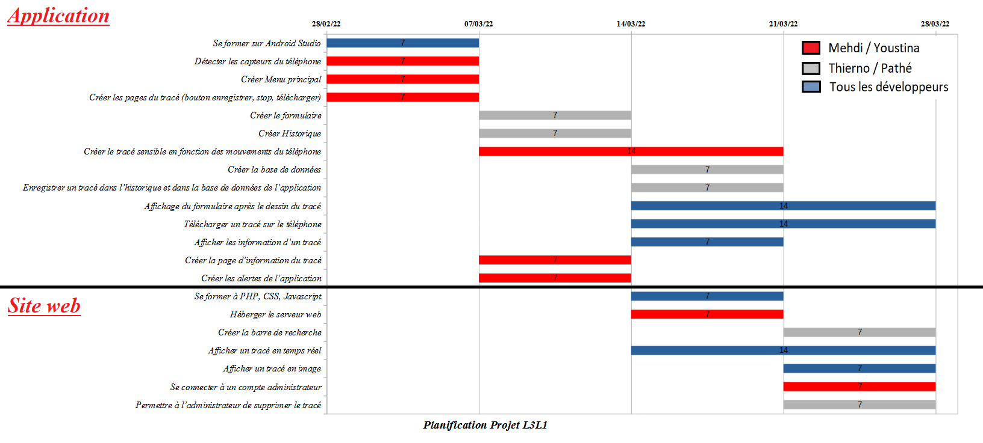
2) Then, from week 5, we started the development phase trying to follow a schedule (gantt chart) with different tasks to be done :
      - I first trained on Android Studio.
      - I worked on the production of the main menu, sensor detection, pop-ups creation, as well as the creation of the sensitive plot according to the movement of the phone. The development phase stops in week 9.
3) I also had the role of project manager from week 4 to 6 by presenting the work to be done for the week to my supervisor.
4) Finally, the next objectives are the finalization of the project with the integration part (week 10) to have a functional code and application and the rendering of the last documents, namely :
      - the user manual (week 11),
      - the installation manual (week 11),
      - the test plan (week 11),
      - internal code documentation (week 11),
      - program source code (week 11),
      - the project report (before the defence),
      - the summary in French and English (before the defence),
      - sound slides (before the defence).

